Stroke patient has stem cell brain injection to help arm movement

PUBLISHED22/11/2015

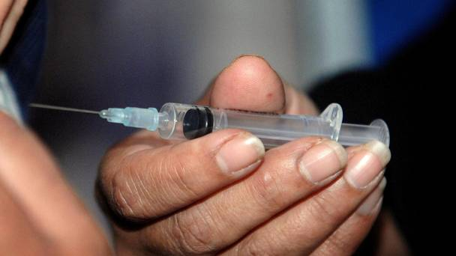

The treatment works by delivering stem cells into the part of the brain that is believed to help generate new nerve cells

A 66-year-old woman has become the first in England to undergo a stem cell brain injection to help recover the use of her arm after she suffered a stroke.
Diederik Bulters, a consultant neurosurgeon at Southampton General Hospital, and his team - which consisted of 17 colleagues - carried out the procedure after the woman lost functional movement in her arm when she suffered a stroke a year ago.
The treatment, which will be trialled on 41 patients as part of a UK-wide study known as Pisces II, works by delivering stem cells into the part of the brain that is believed to help generate new nerve cells.
The technique was first used in 2010 at Glasgow's Southern General Hospital for an early-stage study, which involved a total of 11 patients aged in their 60s, 70s and 80s, which found it was safe and preliminary findings showed promising results.
Every year, around 110,000 people in England suffer a stroke and it is the third largest cause of death behind heart disease and cancer.
A hospital spokesman said: "The majority of strokes are caused by a blockage of blood flow in the brain, known as ischaemic stroke, and around half of all survivors are left with permanent disabilities, with the most common being paralysis of the face, arm and leg on one side of the body.
"After initial treatment for a stroke, which involves having clot-busting drugs administered within several hours of the onset of the condition, there are no existing treatments, other than ongoing rehabilitation, to alleviate the disabilities caused as a result."
Mr Bulters said: "This is a really exciting study and we are delighted to be a part of it and be able to offer some of our patients the opportunity to trial this potentially revolutionary treatment.
"The treatment was tested successfully in a small, early-stage study in Scotland, which showed the technique to be safe, so what we need to do now is quantify how much benefit is derived from it."
He added: "While we have made great strides in this country in treating the onset of a stroke, there is little that can currently be done to improve the lives of so many survivors who are left permanently disabled as a result - but this project could change that."
A second patient, a 72-year-old woman, has now received the injection at Southampton General Hospital and the study is under way at 11 other units in the UK.

